**CMPE-250 Laboratory Exercise Six**

**Secure String I/O and Number Output**

By submitting this report, I attest that its contents are wholly my individual writing about this exercise and that they reflect the submitted code. I further acknowledge that permitted collaboration for this exercise consists only of discussions of concepts with course staff and fellow students; however, other than code provided by the instructor for this exercise, all code was developed by me.



Dean Trivisani

Performed September 3, 2017

Submitted October 17, 2017

Lab Section 01L2

Instructor: Melton

TA: Donald Mannise

Michael Baumgarten

Matthew Toro

Lecture Section 01

Professor: Melton

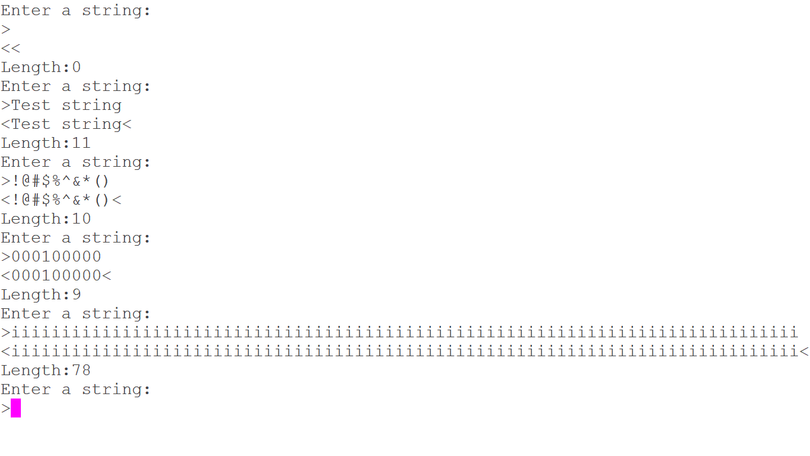

**Symbol Name Value Ov Type Size Object(Section)**

GetStringSB 0x00000175 Thumb Code 72 exercise06.o(MyCode)

PutStringSB 0x000001bd Thumb Code 22 exercise06.o(MyCode)

PutNumU 0x000001d3 Thumb Code 88 exercise06.o(MyCode)

**Memory Ranges**

GetStringSB: 0x00000175 – 0x000001BC

PutStringSB: 0x000001BD – 0x000001D2

PutNumU: 0x000001D3 – 0x0000022B

**Question 1**

The number of user-typed characters stored in the string has to be one fewer than the number of bytes allocated for the string because the total number of bytes includes the one byte used for the null termination character.

**Question 2**

EQU must be used instead of DCD because MAX_STRING is used as the parameter that defines the SPACE allocated for the string buffer, which cannot be done with a constant defined using DCD.